**a-i)** **Visualization of given data set** (**Dataset id: 9-18-9**):

Feature 1 and Feature 2 of the given dataset are plotted against X-axis and Y-axis respectively. Colour *‘red’* is used to mark -1 class while colour *‘green’* is used to mark +1 class from the dataset. We can see that the data is divided into different classes by a curve.

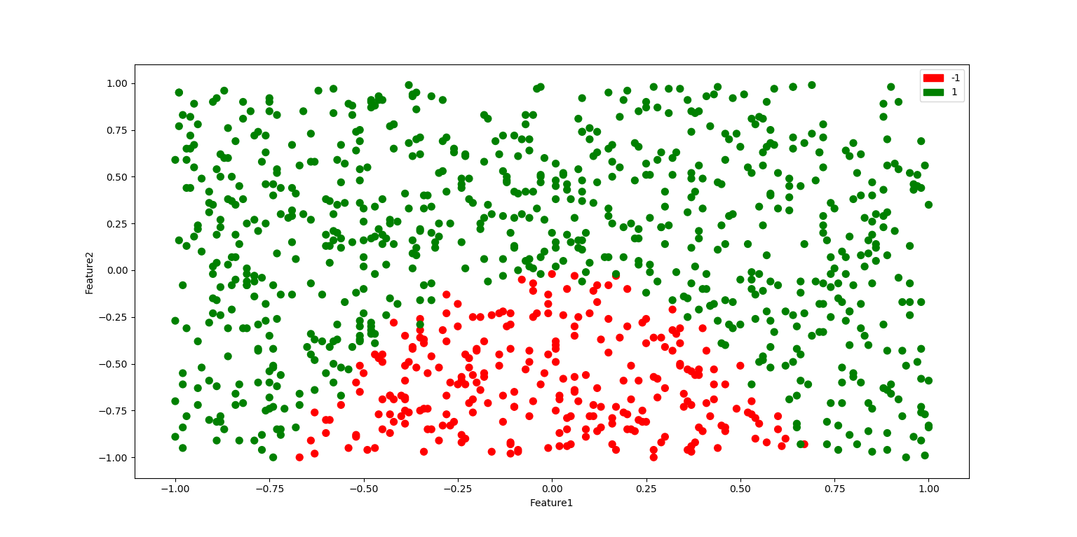

Figure 1: Raw data visualization

**a-ii) Logistic Regression:**

from sklearn.linear_model import LogisticRegression  
  
lr = LogisticRegression()  
lr.fit(X,y)  
  
# Model Parameters and score  
  
print("Logistic Regression intercept: "+str(lr.intercept_))  
print("Logistic Regression coefficients: "+str(lr.coef_))  
print("Logistic Regression score: "+str(lr.score(X,y)))

*Logistic Regression intercept: [2.06877543]*

*Logistic Regression coefficients: [[0.03936939 3.74296068]]*

*Logistic Regression score: 0.8118118118118118*

We are using LogisticRegression model from the Sklearn libray and training the model with given dataset. Since we have 2 parameters, our model should be equivalent to **y = θ1 x1 + θ2 x2 + Intercept.** So as per the outputs **θ1 =** 0.03936939 ; **θ2 =** 3.74296068 ; **Intercept =** 2.06877543. Score 0.81 represents accuracy of the current model, i.e. the model predicts correct output for 81% of the datapoints given to it.

From the output we can clearly see **θ2 >> θ1** This means feature 2 is a bigger deciding factor when compared to feature 1.

**a-iii) Prediction visualization:**

The given dataset has been plotted with *‘red’* colour for -1 class and *‘green’* colour for +1 class. On top of it, predictions made by the model are also plotted with *‘blue’* colour for -1 predicted class and *‘yellow’* for +1 predicted class. The decision boundary is plotted in *‘cyan’* colour.

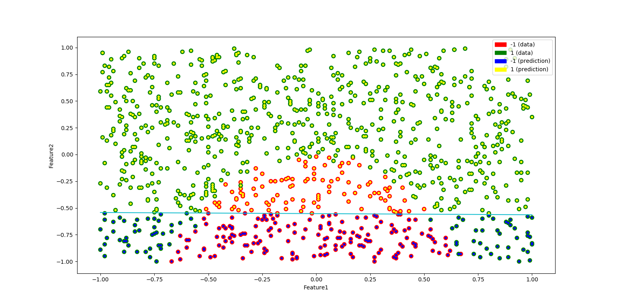

Figure 2: Visualization of predicted values

To obtain the line we can simply solve this equation **‘y = θ1 x1 + θ2 x2 + Intercept’** mentioned above for x1= +1 and x1= -1 and get the values of x2. Then we can just plot a line passing through these two points.

point1= -(lr.intercept_[0]+(lr.coef_[0][0]))/(lr.coef_[0][1]) #x2 value when x1 is +1  
point2= -(lr.intercept_[0]-(lr.coef_[0][0]))/(lr.coef_[0][1]) #x2 value when x1 is -1  
  
plt.plot([1,-1],[point1,point2],'tab:cyan')  
plt.show()

**a-iv) Comparison with training data:**

From the visualization we can see that the training data is divided into two classes by a quadratic curve but the model has simply divided the data into two parts by a straight line at x2 ≈ -0.5 and all data items above this point are classified as +1 and all those which are below are classified as -1.

**b-i) SVM with different values of C:**

In SVM we use hinge loss function ***max(0, 1 − y* θT *x)***. But this loss function can always be forced to 0 if **θ** is large enough, so penalty (**θT θ**) is introduced to get a proper behaviour from the model. The value of C is defined to increase or decrease the importance of penalty in the SVM cost function. So the Final SVM cost function = HingeLossFunction + (Penalty/C). From the equation we can see that a very large value of C will decrease the penalty factor and vice-versa.

After training Linear SVM model for the given dataset on different values of C, following parameters were obtained:

Table 1: SVM parameters for different values of C

|  |  |  |  |  |
| --- | --- | --- | --- | --- |
| **C** | **θ1** | **θ2** | **Intercept** | **Score** |
| 0.001 | -0.01 | 0.35 | 0.33 | 0.75 |
| 0.1 | 0.02 | 1.29 | 0.69 | 0.81 |
| 1 | 0.02 | 1.38 | 0.73 | 0.81 |
| 100 | 0.03 | 1.40 | 0.69 | 0.82 |
| 1000 | 1.40 | 0.92 | 0.24 | 0.65 |

Analysis of this table and the impact of C on the model is discussed in part b-iii)

**b-ii) Prediction visualization for all models:**

Similar to above visualizations baseline data and prediction data are plotted on the same chart along with the decision boundary line in ‘cyan’ colour.

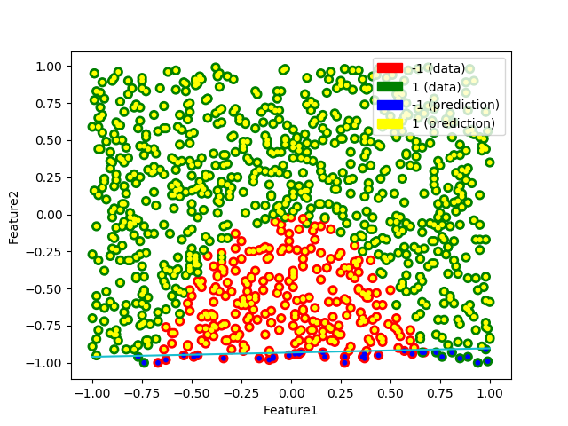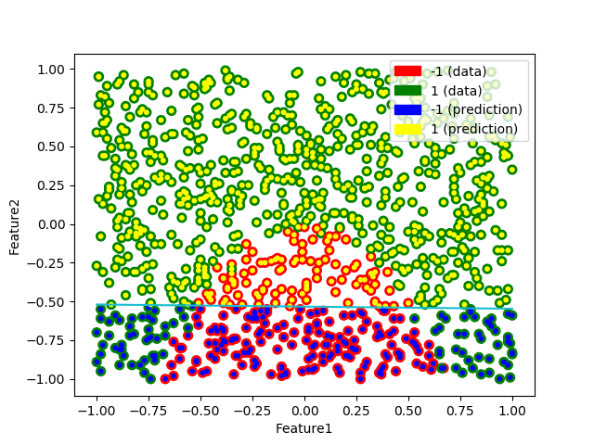

Figure 3: SVM with C=0.001 Figure 4: SVM with C=0.1

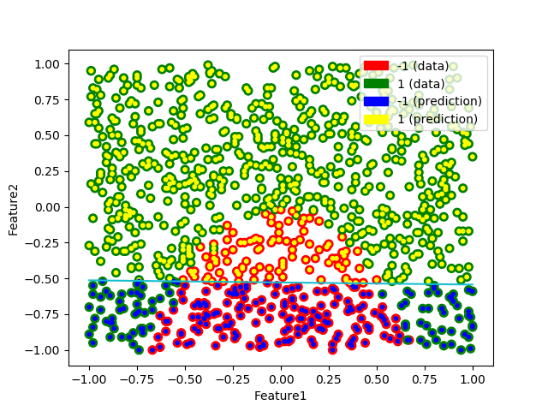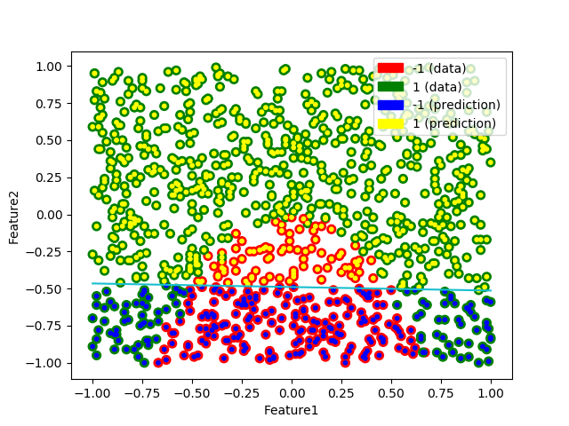

Figure 5: SVM with C=1 Figure 6: SVM with C=100

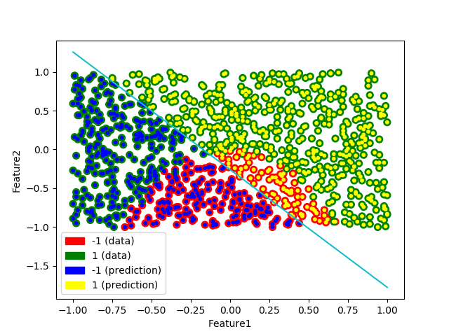

Figure 7: SVM with C=1000

**b-iii) Impact of C**

Based on the values provided in Table 1 and figures above, we can infer that the accuracy of the model is good when values of C is close to 1. For C=0.001 the penalty carries too much importance and values of **θ** are not able to scale up properly resulting in poor accuracy score. We can see this in Figure 3, almost all data points are predicted in class +1 and model is not able to predict properly. On the other hand for C=1000 , the penalty has too less importance and we can see **θ** values become too large but accuracy is decreased. The Figure 7 shows the abnormal behaviour of the model due to high value of C.

**b-iv) Comparison with Logistic Regression in part a**

The SVM model is fairly similar to the Logistic Regression model in part a when the values of C are close to 1. We can compare them based on accuracy score. For both the models, accuracy is approximately close to 81% for the right value of C, which can be confirmed by looking at the decision boundaries of both the models provided in the plots above. But for very small / very large values of C the SVM model drops accuracy and loses the underlying pattern in data, so it is important to have correct values of C when using SVM.

**c-i) Logistic Regression with additional squared features**

X1_sq=np.square(df.iloc[:,0]) # Square of first parameter  
X2_sq=np.square(df.iloc[:,1]) # Square of second parameter  
  
X_inputs=np.column_stack((X1,X2,X1_sq,X2_sq))  
  
# Train the Logistic Regression  
lr_sq = LogisticRegression(penalty='none')  
lr_sq.fit(X_inputs,y)  
  
print("Squared Logistic Regression intercept: "+str(lr_sq.intercept_))  
print("Squared Logistic Regression coefficients: "+str(lr_sq.coef_))  
print("Squared Logistic Regression score: "+str(lr_sq.score(X_inputs,y)))

*Squared Logistic Regression intercept: [0.79755297]*

*Squared Logistic Regression coefficients: [[ 1.2249378 44.61868094 77.33647427 6.91293073]]*

*Squared Logistic Regression score: 0.986986986986987*

After using the LogisticRegression with additional squared features our model should be equivalent to

**y = θ1 x1 + θ2 x2 + θ3 (x1)2 + θ4 (x2)2 + Intercept.** So as per the outputs **θ1 =** *1.2249378* ; **θ2 =** *44.61868094* ; **θ3 =** *77.33647427* ; **θ4 =** *6.91293073*; **Intercept =** *0.79755297*. Score 0.98 represents accuracy of the current model, i.e. the model predicts correct output for 98% of the datapoints given to it.

**c-ii) Visualization and comparison**

Similar to above plots we have depicted baseline data and the prediction data on the same graph along with the decision boundary.

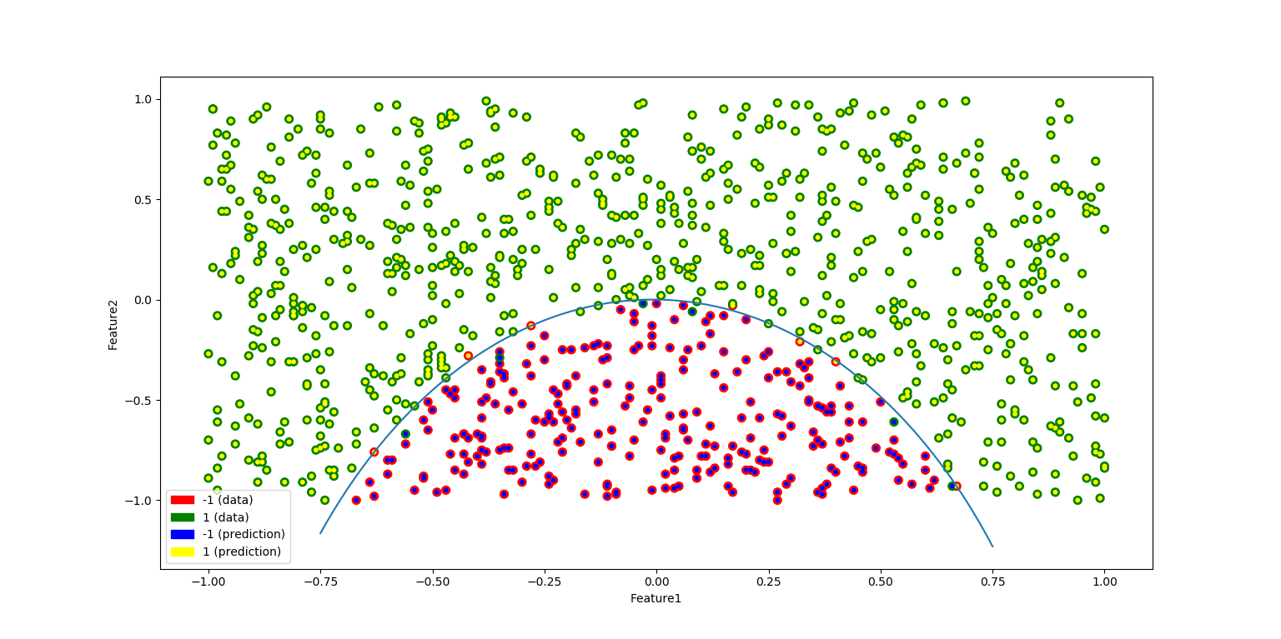

Figure 8: Logistic Regression with squared inputs

Comparing with the models in part a and part b we can infer that addition of the squared inputs to our model training has improved the results drastically. We can see **θ2 =** *44.61* ; **θ3 =** *77.33* are significantly higher than **θ1 =** *1.22* and **θ4 =** *6.91* . This suggests that **(x2)** and **(x1)2** are co-related to each other in such a way that the data points can be classified into +1 and -1 in a linearly separable way. This why the accuracy has jumped up to 98% as compared to 80% in the models in part a and part b, as these models did not have the squared features (or linearly separable features) as their inputs.

In the figure below we have plotted baseline data with **(x1)2** on the X axis and **(x2)** on the Y axis. Class -1 is represented in *‘red’* and class +1 is represented in *‘green’*. From the figure we can clearly see that we can draw a straight line to separate +1 and -1 classes from the dataset. That’s why these two inputs are the deciding factor for the new model.

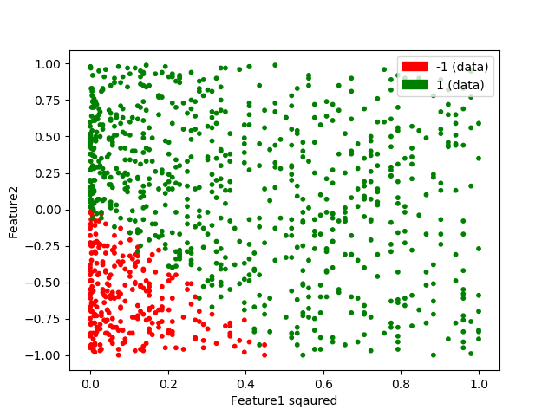

Figure 9: Plot of (feature1)squared against feature2

**c-iii) Comparison with a baseline model:**

If we create a baseline model which always predict most common class, the accuracy of that model for the given data set would be (count of common class) / (total count). For the given data set this turns out to be 737/999=0.73 This means even a dumb model has an accuracy of **73%**. When we compare this with models in part a and part b which have accuracy close to 81% this does not seem to be a significant increase from the baseline model. But comparing it with accuracy of **98% for model in part c** we can say model c is much more effective than the baseline model.

**c-iv) Decision boundary:**

The model represents equation **y = θ1 x1 + θ2 x2 + θ3 (x1)2 + θ4 (x2)2 + Intercept**

If we substitute some values of x1 we can solve the quadratic equation to find the corresponding values of x2. We can compare this with **ax2+bx+c = 0** and find the root by using **(-b + sqrt (b2 – 4ac))/2a** and then plot the curve.

x1a = np.linspace(-0.75,0.75,100) # Random x1 values from -0.75 to 0.75  
  
# comparing with a*x*x + b*x + c = 0  
a=lr_sq.coef_[0][3]  
b=lr_sq.coef_[0][1]  
  
x2a = []  
x2b = []  
  
# find values of c and solve for x2  
for k in x1a:  
 c=( (lr_sq.coef_[0][0]*k) + (lr_sq.coef_[0][2]*k*k))  
 tt =np.absolute(((b*b) - (4*a*c)))  
 root1 = (-b + np.sqrt(tt))/(2*a)  
 x2a.append(root1)  
  
plt.plot(x1a,x2a)  
plt.show()

**APPENDIX**

* Code referred from lecture slides and sklearn, matplotlib, numpy api documentation.

Python code:

# Name: Omkar Pramod Padir  
# Student Id: 20310203  
# Dataset id:9-18-9  
# Course: Machine Learning CS7CS4  
  
  
import numpy as np  
import pandas as pd  
import matplotlib.pyplot as plt  
import matplotlib.colors as mcolors  
import matplotlib.patches as mpatches  
  
# function to plot given data  
def PlotBaselineData():  
 plt.xlabel('Feature1')  
 plt.ylabel('Feature2')  
  
 plt.scatter(X1, X2, 50, y, cmap=cmap)  
  
  
 plt.legend(handles=[red_patch, green_patch])  
  
cmap, norm = mcolors.from_levels_and_colors([-1, 0, 1], ['red', 'green'])  
red_patch = mpatches.Patch(color='red', label='-1 (data)')  
green_patch = mpatches.Patch(color='green', label='1 (data)')  
  
# Part A starts here  
  
# Load data and create arrays of input and output  
  
df = pd.read_csv("ML_W2_DATA.csv")  
  
X1=df.iloc[:,0]  
X2=df.iloc[:,1]  
X=np.column_stack((X1,X2))  
y=df.iloc[:,2]  
  
# Plot the baseline data  
  
PlotBaselineData()  
plt.show()  
  
# Create and fit Logistic Regression Model  
  
from sklearn.linear_model import LogisticRegression  
  
lr = LogisticRegression()  
lr.fit(X,y)  
  
# Model Parameters and score  
  
print("Logistic Regression intercept: "+str(lr.intercept_))  
print("Logistic Regression coefficients: "+str(lr.coef_))  
print("Logistic Regression score: "+str(lr.score(X,y)))  
  
PlotBaselineData()  
cmap2, norm = mcolors.from_levels_and_colors([-1,0,1], ['blue', 'yellow'])  
blue_patch = mpatches.Patch(color='blue', label='-1 (prediction)')  
yellow_patch = mpatches.Patch(color='yellow', label='1 (prediction)')  
plt.legend(handles=[red_patch,green_patch,blue_patch,yellow_patch])  
plt.scatter(X1, X2, 10, lr.predict(X), cmap=cmap2, marker="o")  
  
# Solve the equation to get x2 values by using coefficient and intercept of the model  
  
point1= -(lr.intercept_[0]+(lr.coef_[0][0]))/(lr.coef_[0][1]) #x2 value when x1 is +1  
point2= -(lr.intercept_[0]-(lr.coef_[0][0]))/(lr.coef_[0][1]) #x2 value when x1 is -1  
  
plt.plot([1,-1],[point1,point2],'tab:cyan')  
plt.show()  
  
  
# Part B starts here  
  
  
from sklearn.svm import LinearSVC  
  
# Train SVM models for different values of C  
  
lsvc_001=LinearSVC(C=0.001).fit(X,y)  
lsvc_point1=LinearSVC(C=0.1).fit(X,y)  
lsvc_1=LinearSVC(C=1).fit(X,y)  
lsvc_100=LinearSVC(C=100).fit(X,y)  
lsvc_1000=LinearSVC(C=1000).fit(X,y)  
  
svc_arr=[lsvc_001,lsvc_point1,lsvc_1,lsvc_100,lsvc_1000]  
svc_name=['SVM, C=0.001','SVM, C=0.1','SVM, C=1','SVM, C=100','SVM, C=1000']  
  
for i in range(5):  
 print("For model "+svc_name[i])  
 print("Intercept: " + str(svc_arr[i].intercept_))  
 print("Coefficients: " + str(svc_arr[i].coef_))  
 print("Score: " + str(svc_arr[i].score(X,y)))  
  
# function to plot prediction data points of the model  
def PlotSVMData(model):  
 plt.scatter(X1, X2, 10, model.predict(X), cmap=cmap2, marker="o")  
 plt.legend(handles=[red_patch,green_patch,blue_patch, yellow_patch])  
  
# function to plot decision boundary of the model  
def PlotLine(lr):  
 point1 = -(lr.intercept_[0] + (lr.coef_[0][0])) / (lr.coef_[0][1]) # x2 value when x1 is +1  
 point2 = -(lr.intercept_[0] - (lr.coef_[0][0])) / (lr.coef_[0][1]) # x2 value when x1 is -1  
  
 plt.plot([1, -1], [point1, point2], 'tab:cyan')  
  
# plot all svm models  
for m in svc_arr:  
 PlotBaselineData()  
 PlotSVMData(m)  
 PlotLine(m)  
 plt.show()  
  
  
# Part C starts here  
  
X1_sq=np.square(df.iloc[:,0]) # Square of first parameter  
X2_sq=np.square(df.iloc[:,1]) # Square of second parameter  
  
X_inputs=np.column_stack((X1,X2,X1_sq,X2_sq))  
  
# Train the Logistic Regression  
lr_sq = LogisticRegression(penalty='none')  
lr_sq.fit(X_inputs,y)  
  
print("Squared Logistic Regression intercept: "+str(lr_sq.intercept_))  
print("Squared Logistic Regression coefficients: "+str(lr_sq.coef_))  
print("Squared Logistic Regression score: "+str(lr_sq.score(X_inputs,y)))  
  
PlotBaselineData()  
plt.scatter(X1, X2, 10, lr_sq.predict(X_inputs), cmap=cmap2, marker="o")  
plt.legend(handles=[ red_patch,green_patch,blue_patch, yellow_patch])  
  
# plot decision boundary  
x1a = np.linspace(-0.75,0.75,100) # Random x1 values from -0.75 to 0.75  
  
# comparing with a*x*x + b*x + c = 0  
a=lr_sq.coef_[0][3]  
b=lr_sq.coef_[0][1]  
  
x2a = []  
x2b = []  
  
# find values of c and solve for x2  
for k in x1a:  
 c=( (lr_sq.coef_[0][0]*k) + (lr_sq.coef_[0][2]*k*k))  
 tt =np.absolute(((b*b) - (4*a*c)))  
 root1 = (-b + np.sqrt(tt))/(2*a)  
 x2a.append(root1)  
  
plt.plot(x1a,x2a)  
plt.show()  
  
# Plot of x1*x1 against x2. Just for reference  
plt.xlabel('Feature1 sqaured')  
plt.ylabel('Feature2')  
plt.scatter(X1_sq, X2, 10, y, cmap=cmap)  
plt.legend(handles=[red_patch,green_patch])  
plt.show()  
  
# Comparison with baseline predictor  
count_p1=0  
count_m1=0  
total=0  
for t in y:  
  
 if(t==-1):  
 count_m1=count_m1+1  
 else:  
 count_p1=count_p1+1  
 total=total+1  
  
print(count_p1 , count_m1)  
if count_p1 > count_m1:  
 print("Accuracy of baseline predictor: "+str(count_p1/total))  
else:  
 print("Accuracy of baseline predictor: " + str(count_m1/total))